1.

a. AMPL Software installed on the local folder called Desktop



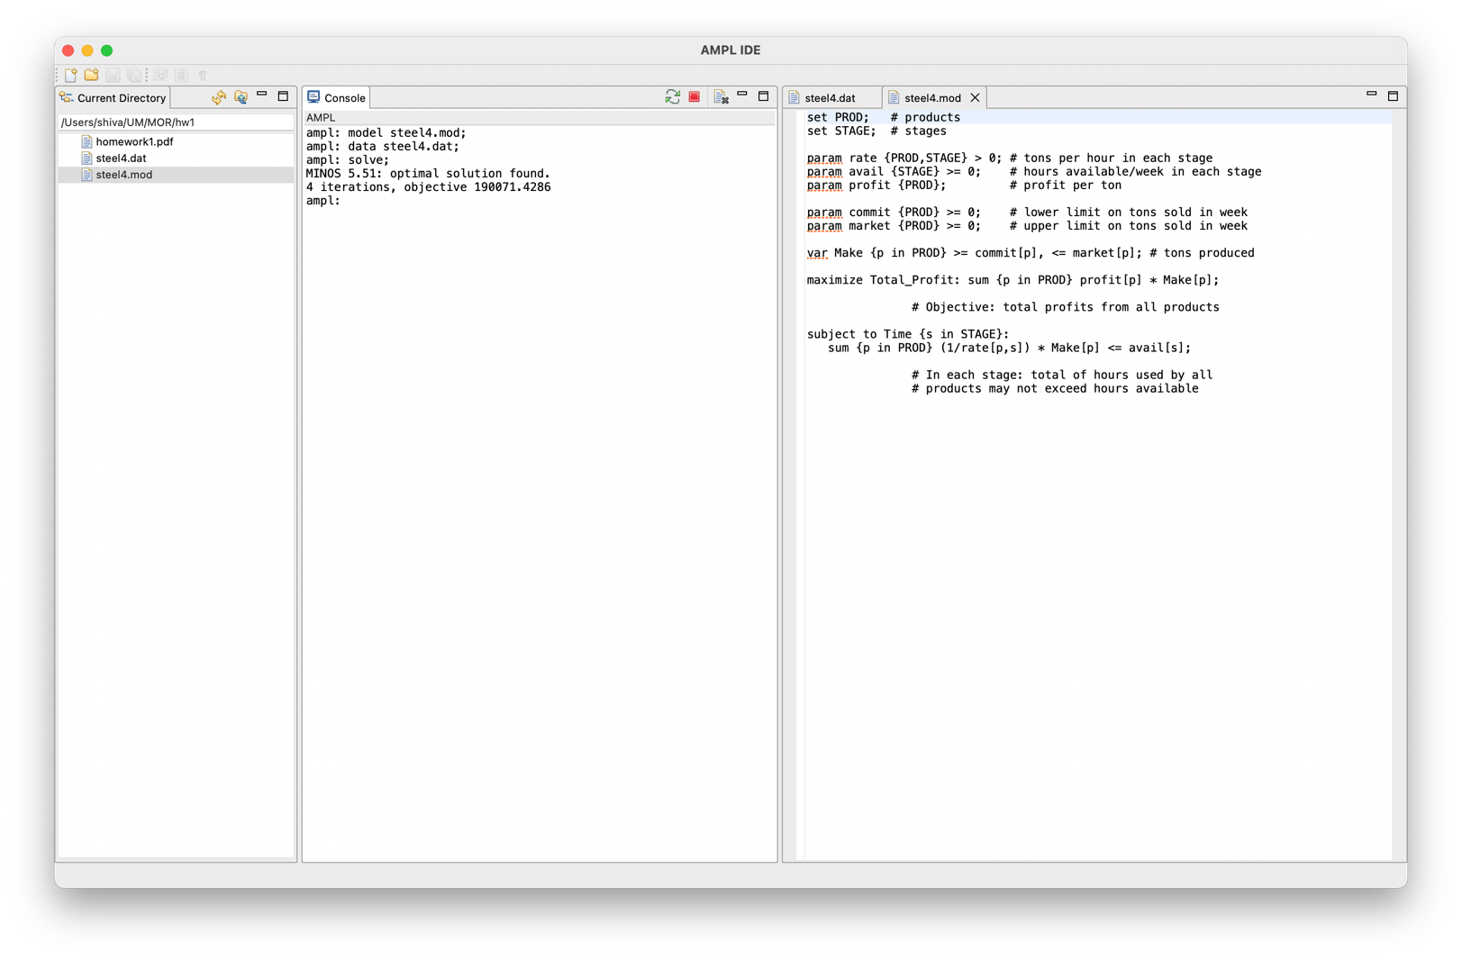

The optimal objective value should be reported as 190071.4286. accurately matches with the above AMPL prompt output.

2.

a.

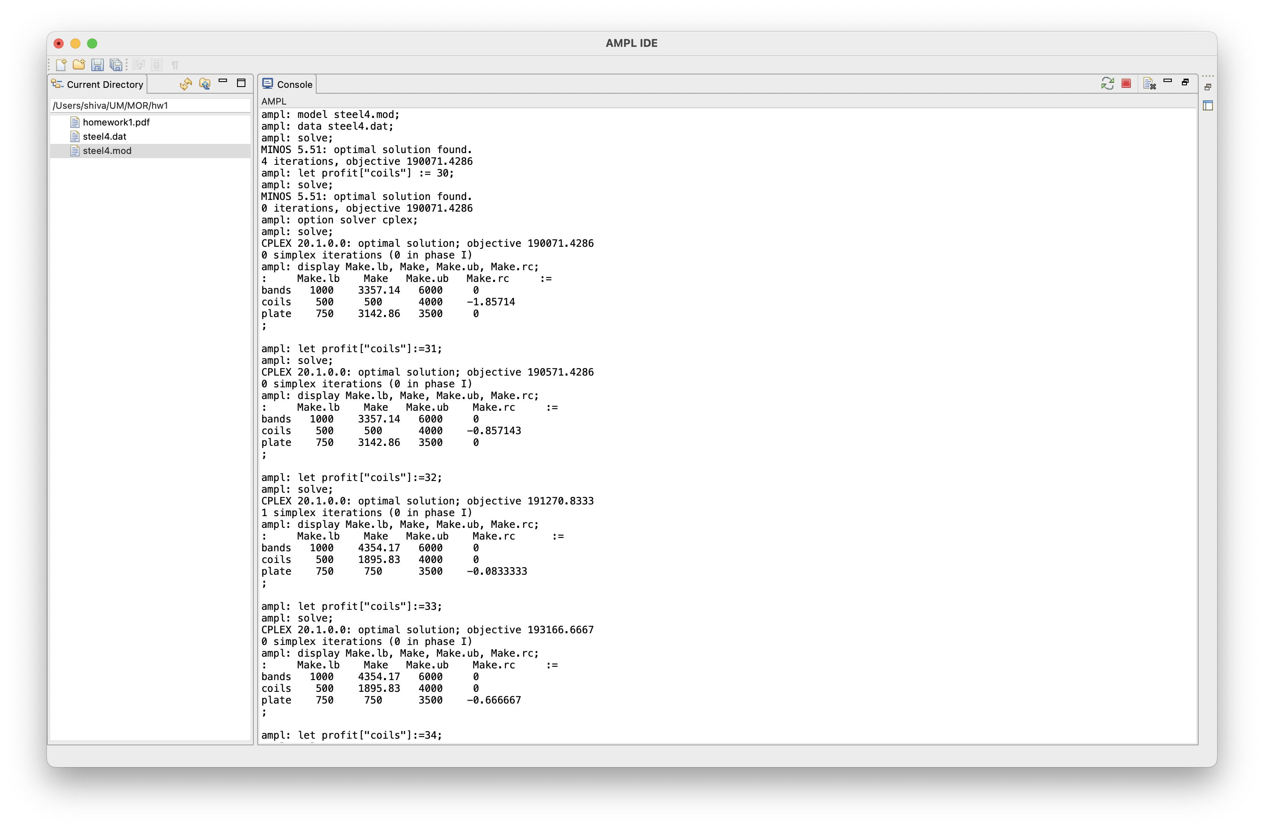

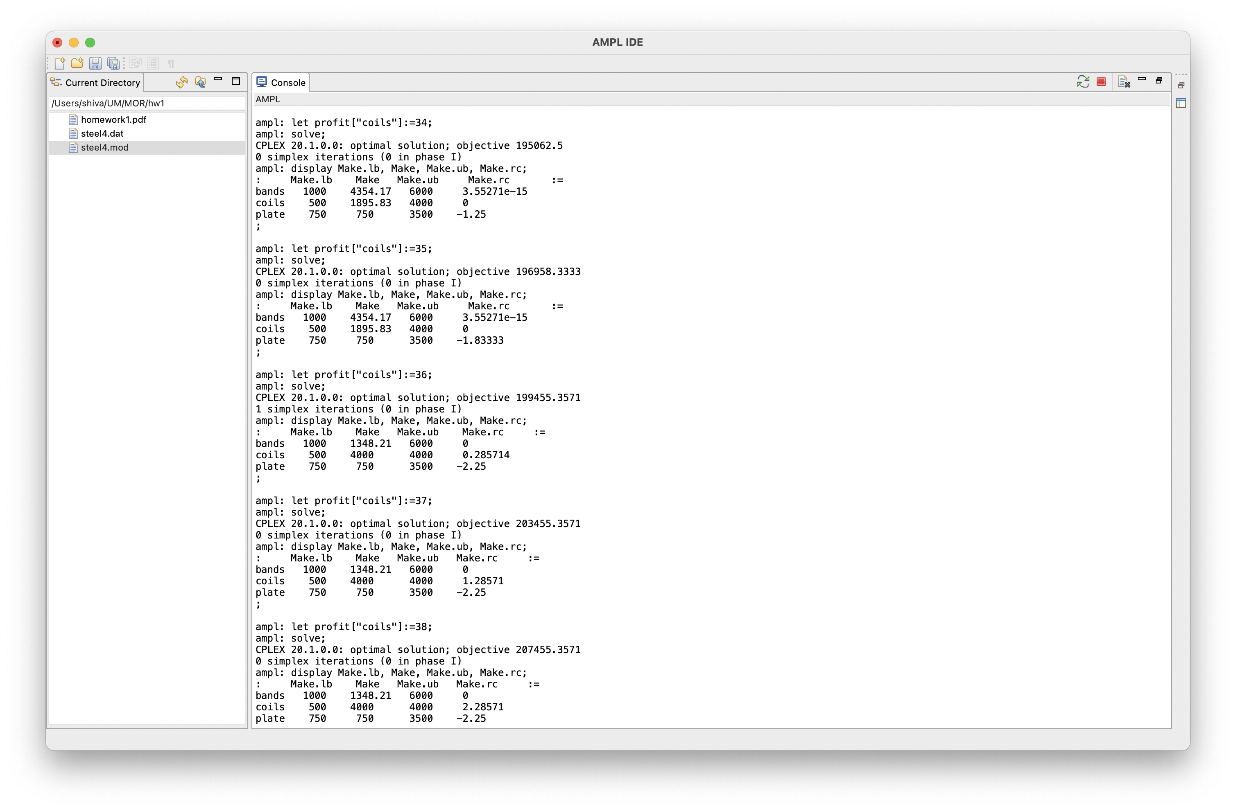

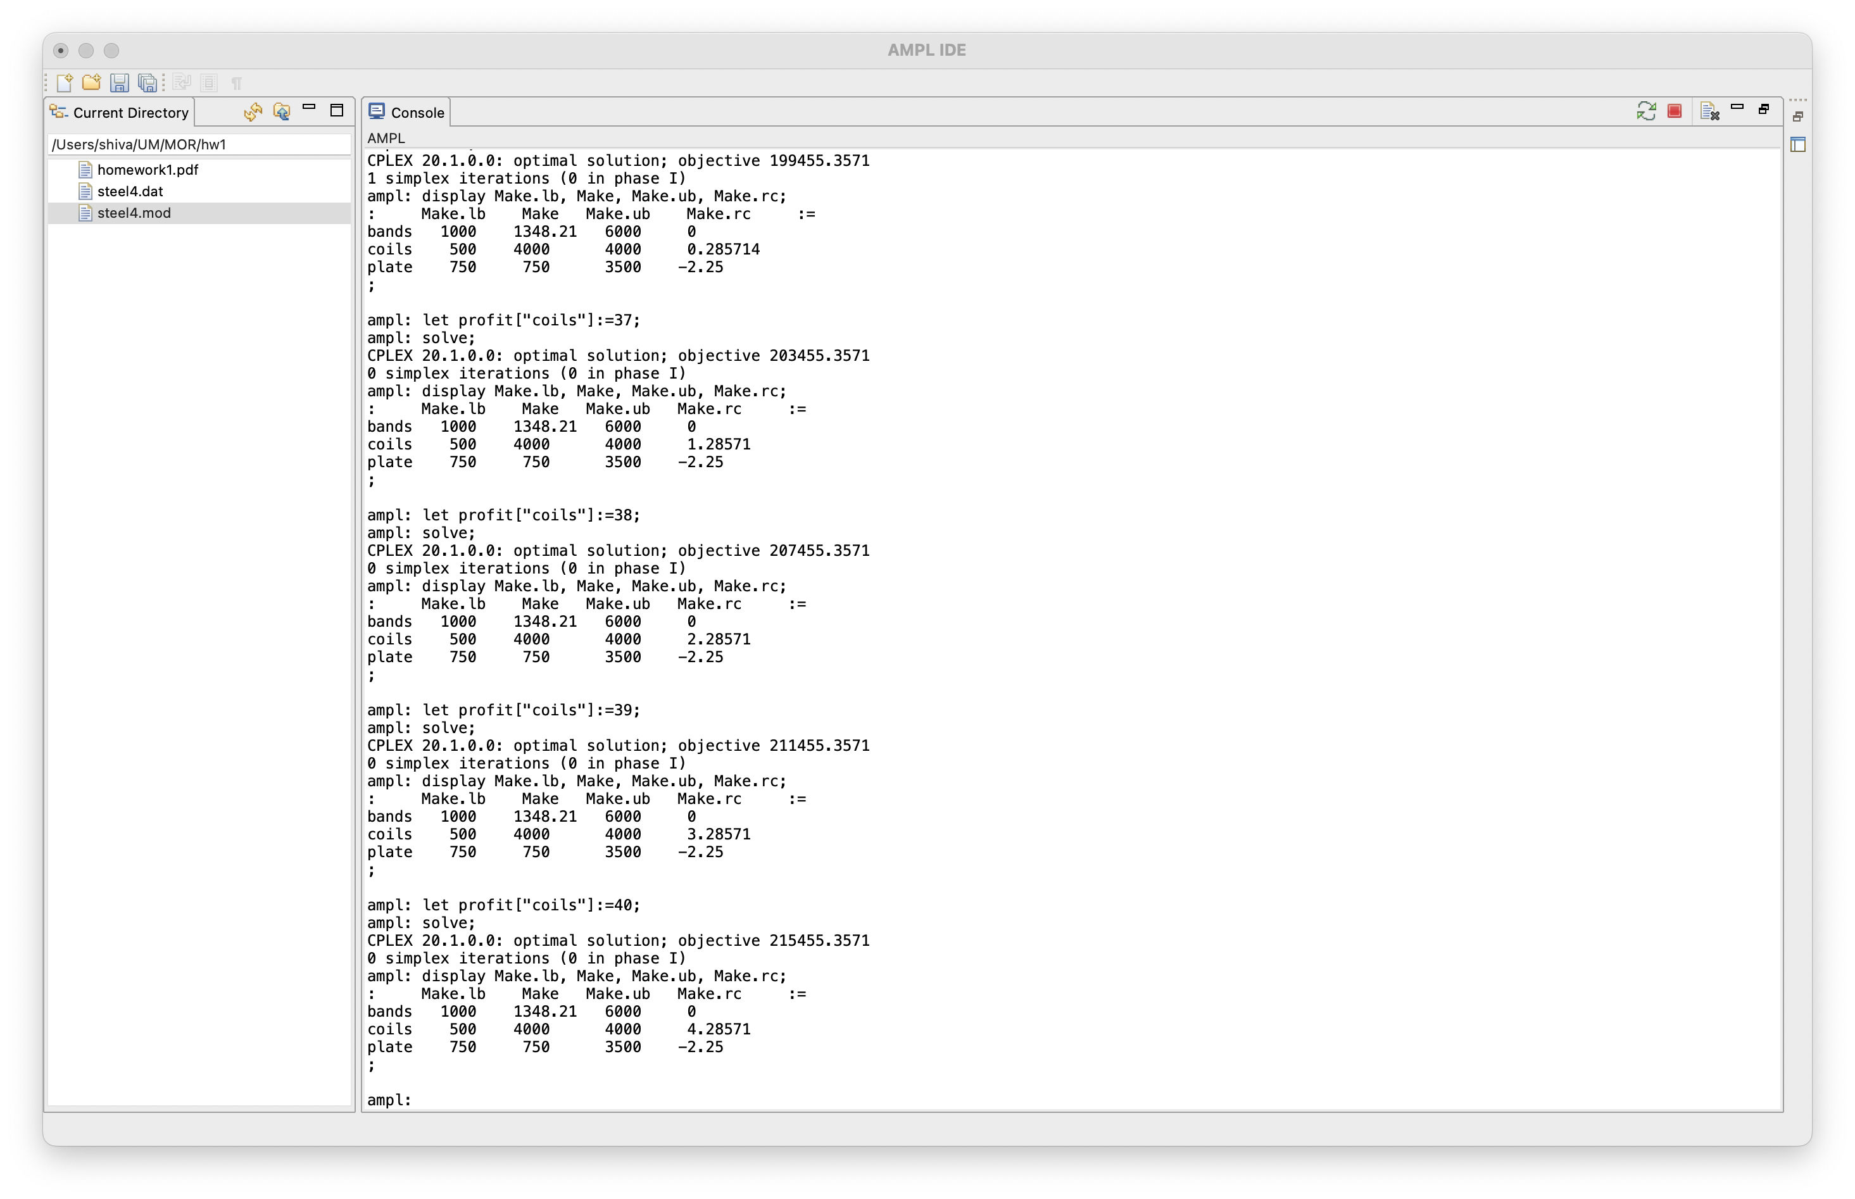

As we can see, the output of coils surpasses 500 and rises to 1895.83 following a $2 increase in the profit per ton of coils. The manufacturing of coils now rises to 4000 after a $4 increase. As a result, we see that the connection between coil production and profit per ton of coils is linear.

b) Solution:

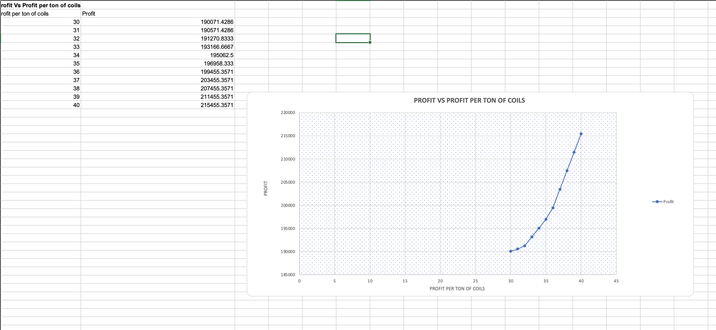

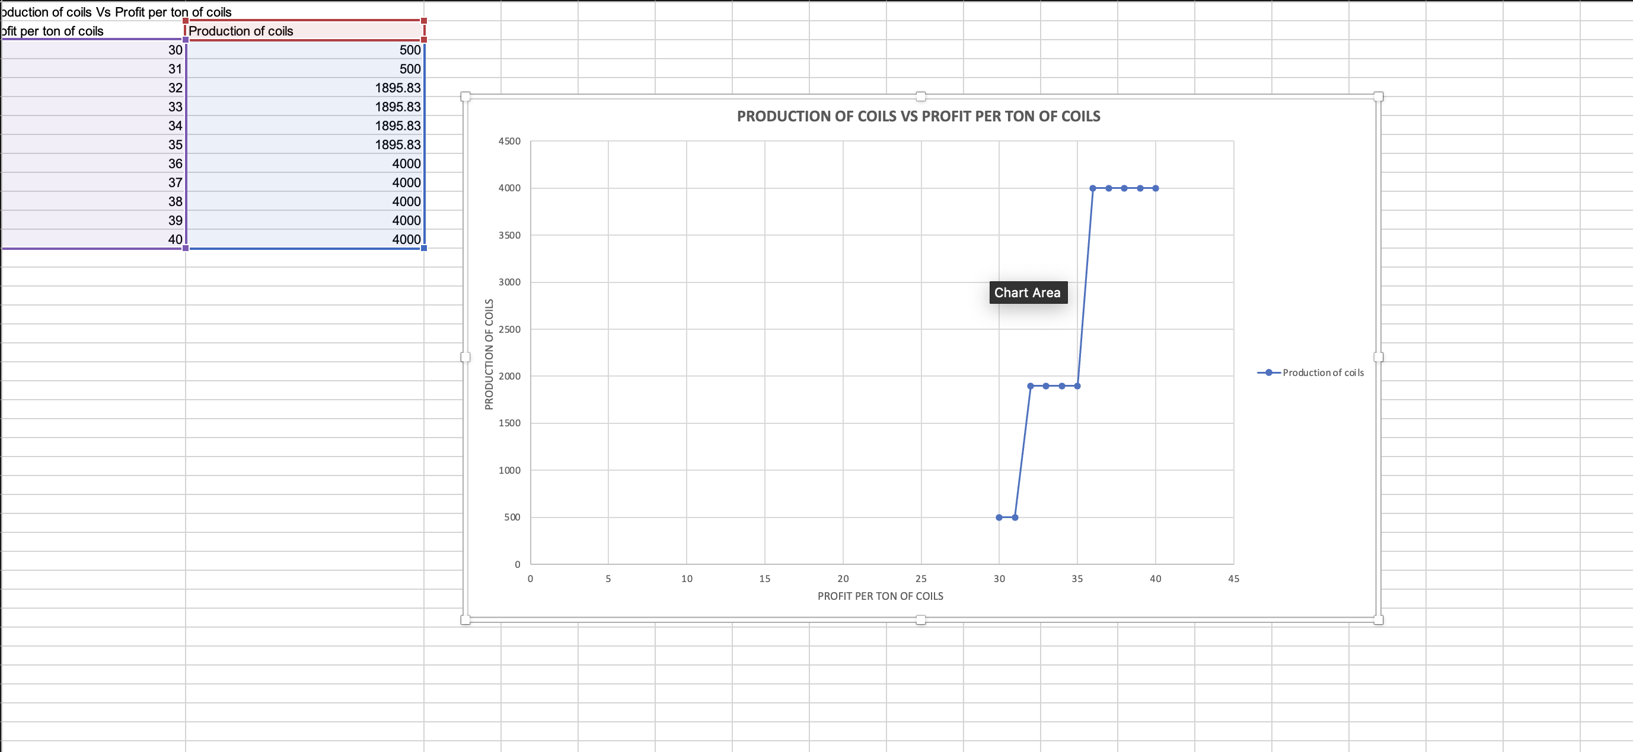

3.

Solution:

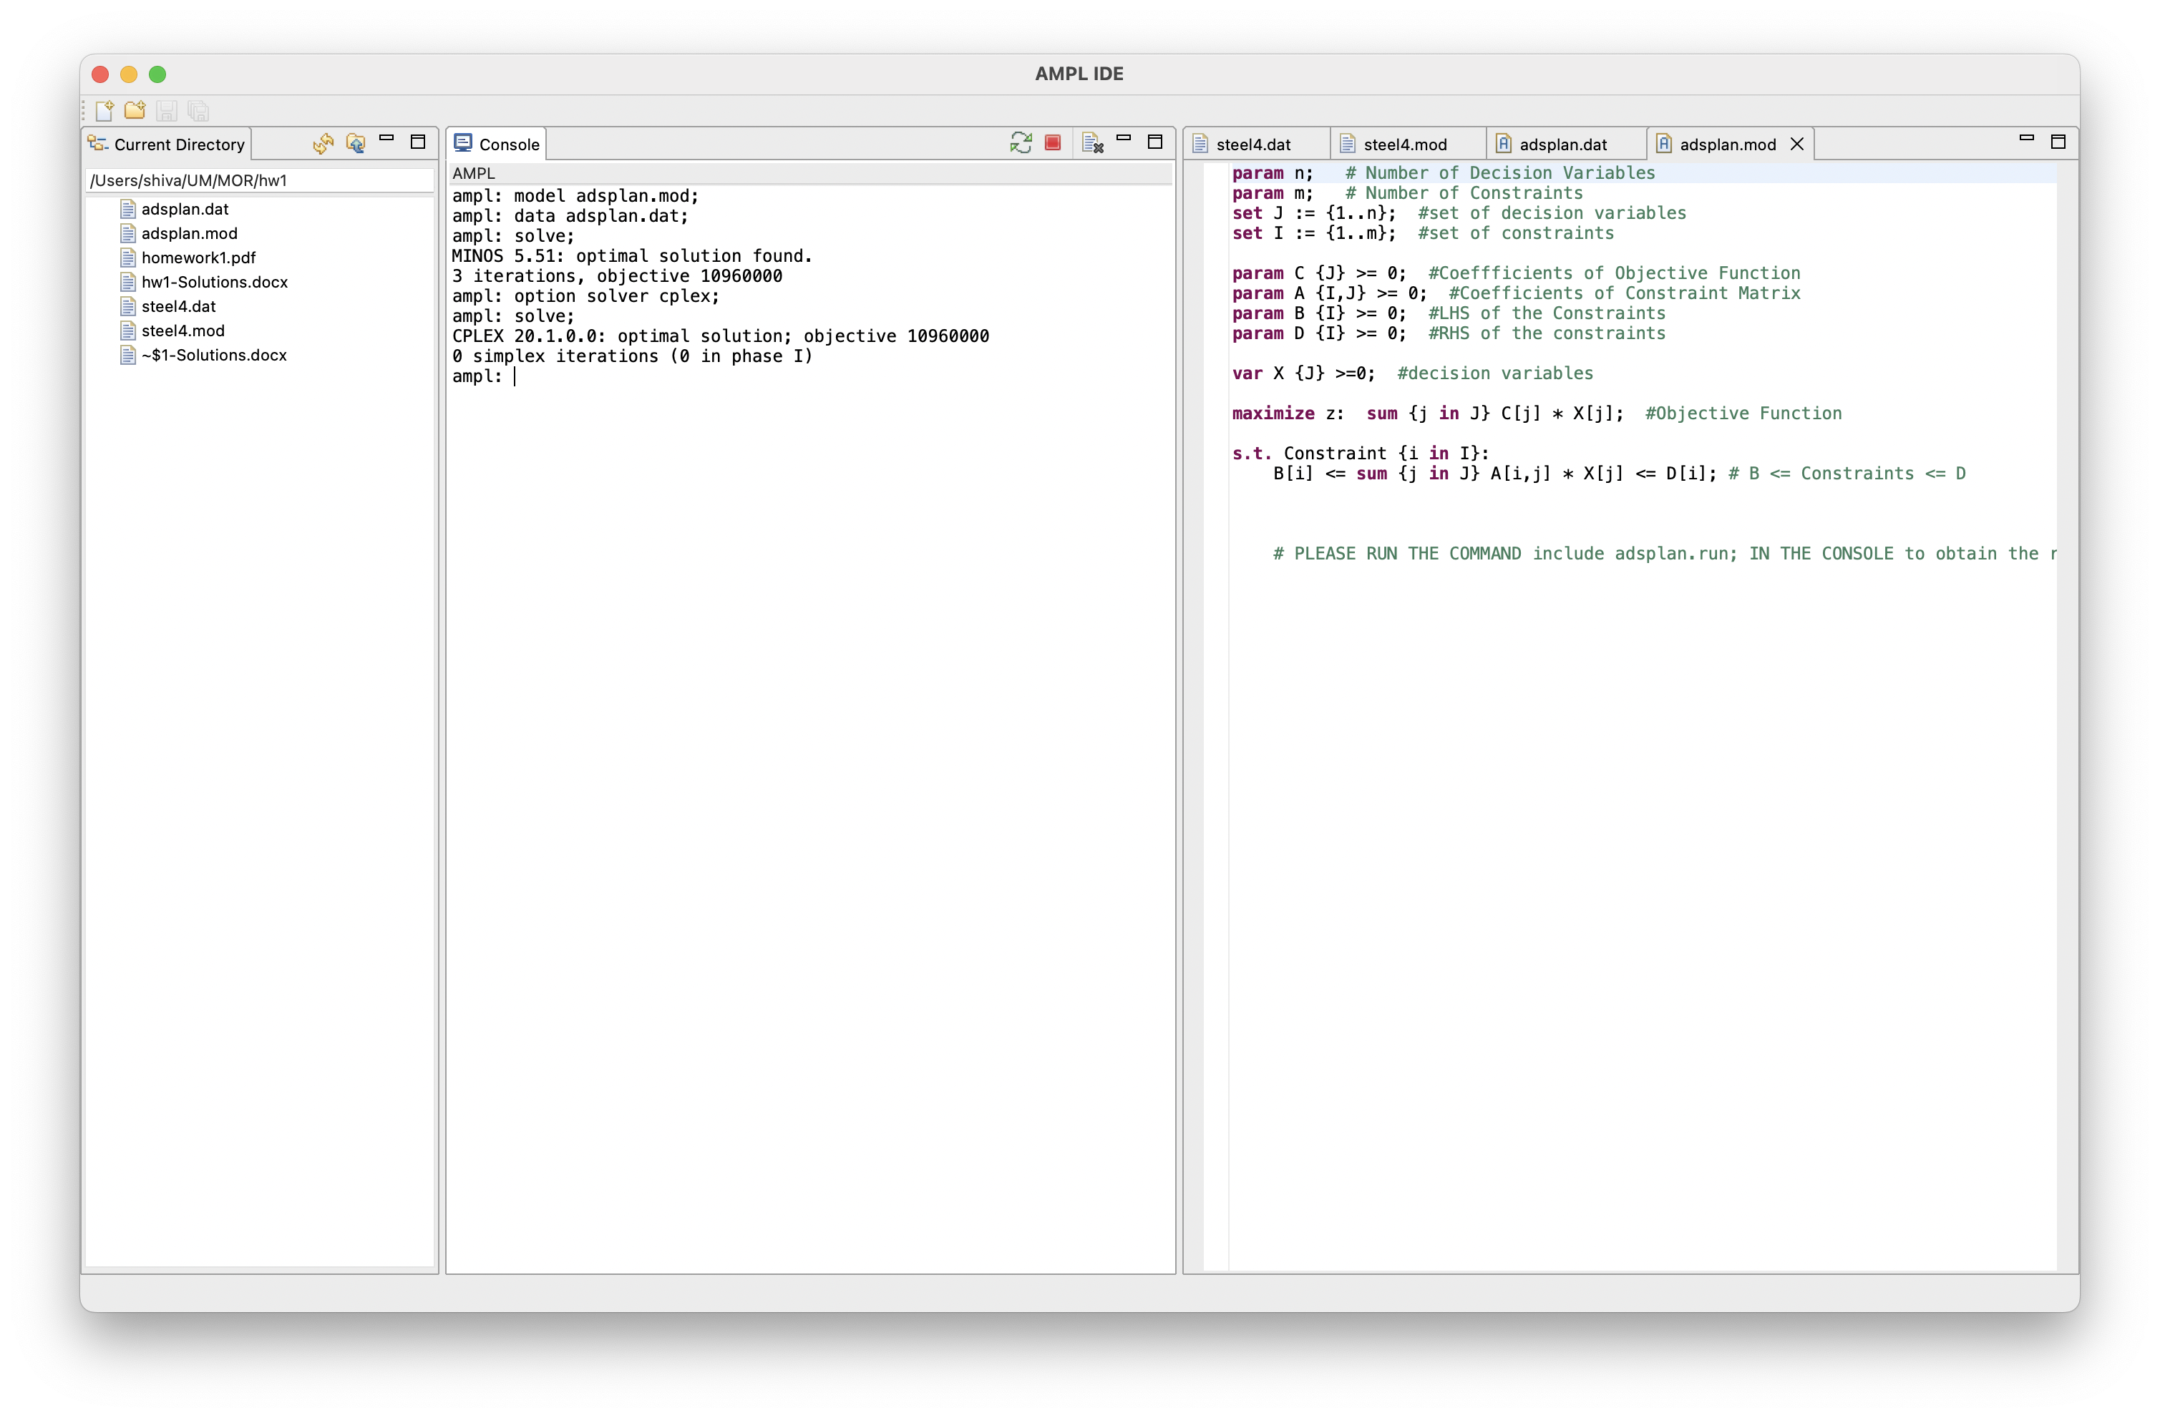

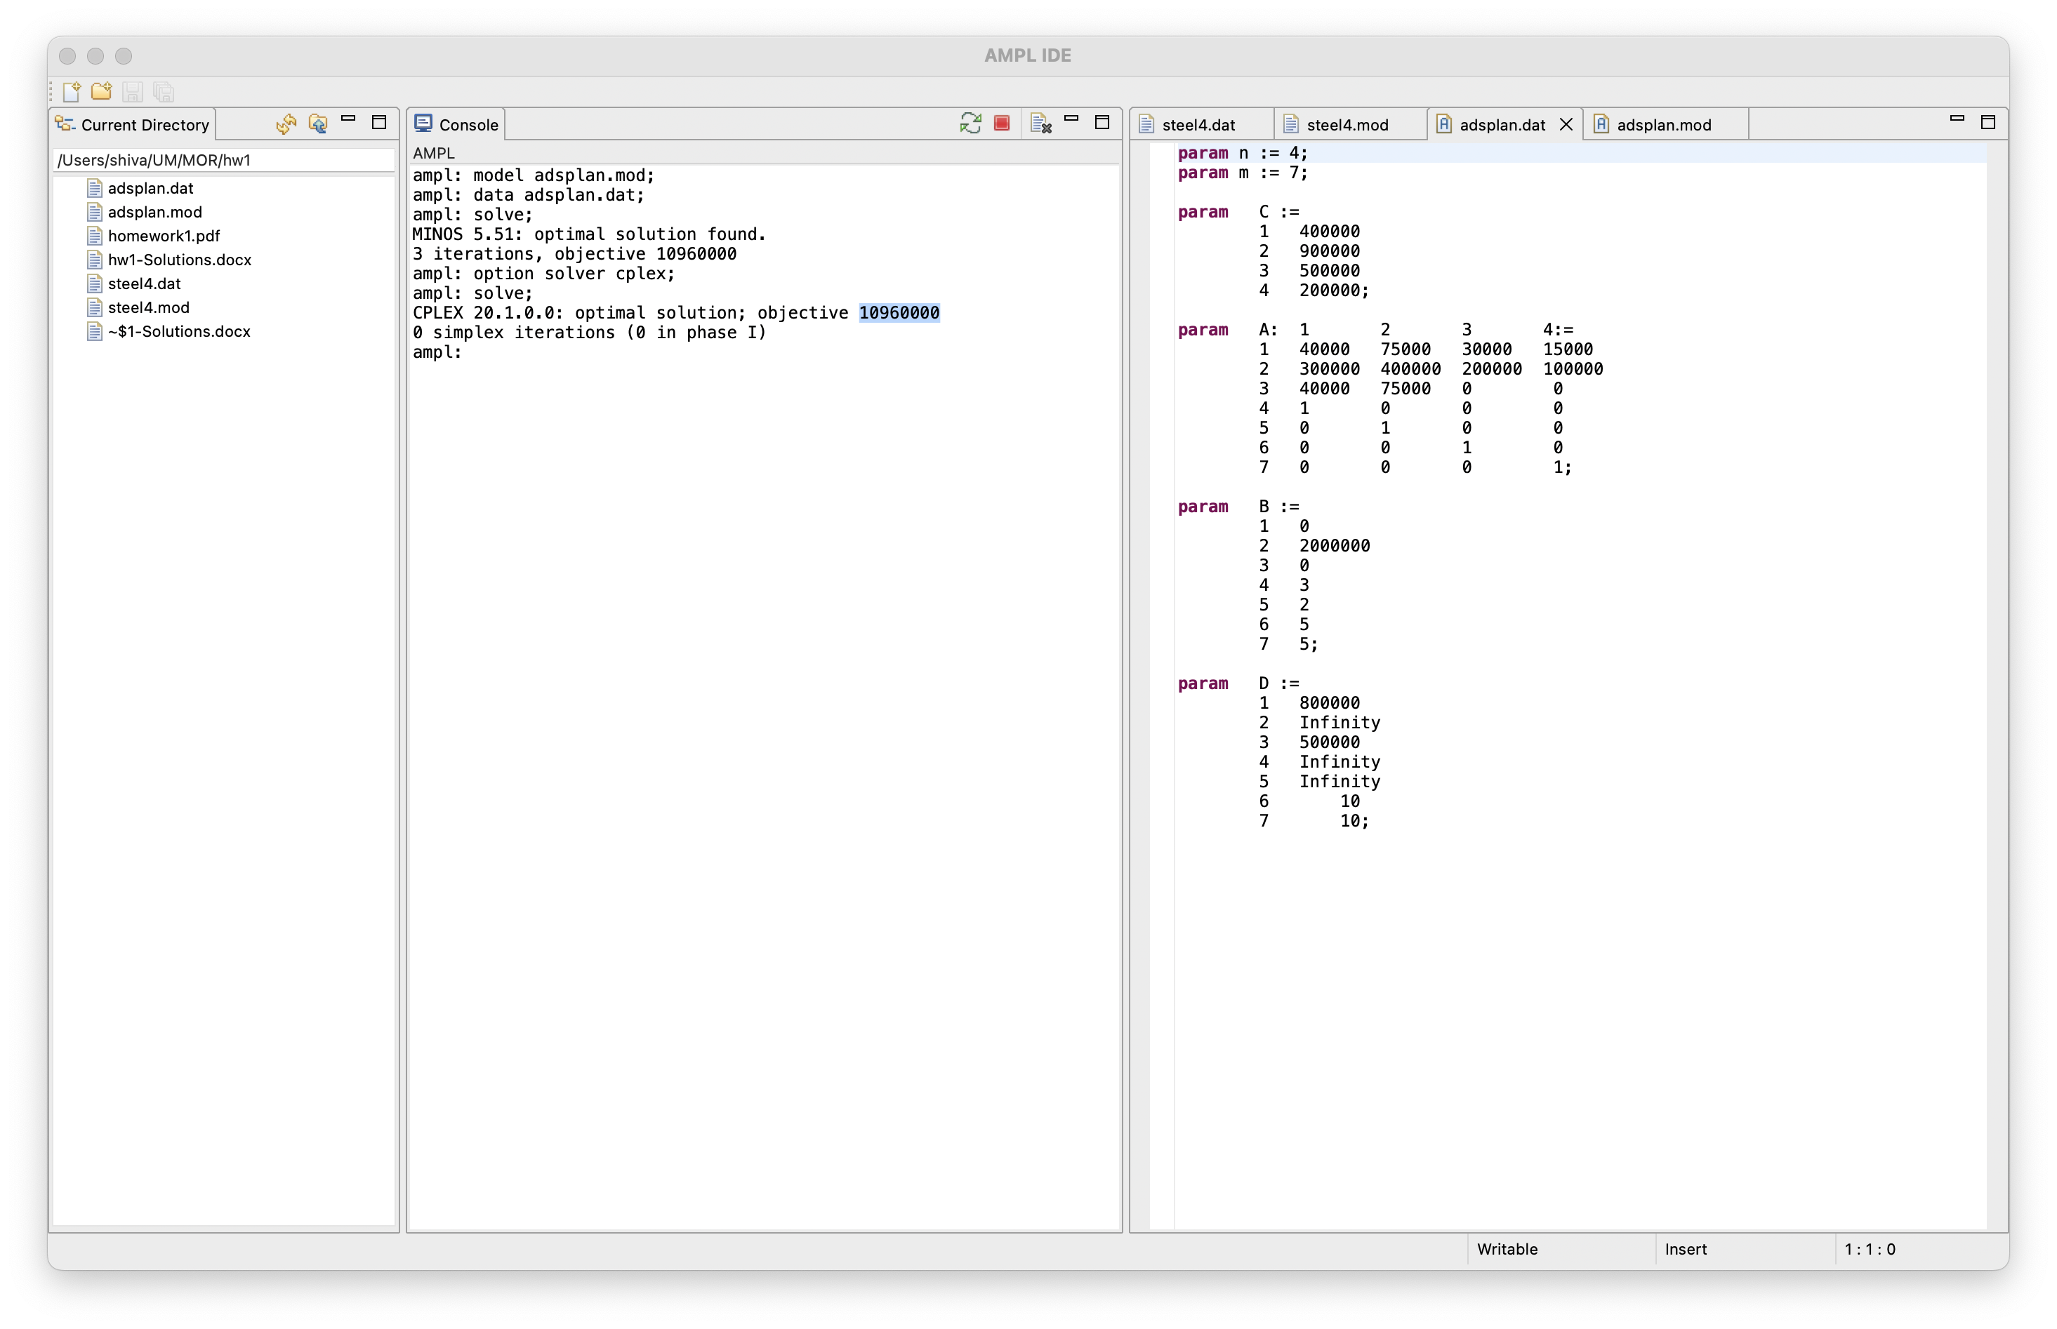

The optimal objective value should be reported as 10960000

Let the amount of advertising units purchased for radio, magazines, daytime television, and prime time television, respectively, be x1, x2, x3, and x4.

All potential clients who were contacted (in thousands)= = 400x1 + 900x2 + 500x3 + 200 x4

 These factors illustrate how the advertising budget is constrained=

40,000x1 + 75,000x2 + 30,000x3 + 15,000x4 ≦ 800,000.

The limitation on the proportion of female clients who are reached by the advertising campaign is as follows=300,000x1 + 400,000x2 + 200,000x3 + 100,000x4 ≧ 2,00,000.

the following are restrictions on television advertising= 40,000x1 + 75,000x2 ≦ 500,000

x1 ≧ 3

x2 ≧ 2.

Since radio and magazine advertising units should range from 5 to 10, the following restrictions apply

5 ≦ x3 ≦ 10

5 ≦ x4 ≦ 10.

The complete linear programming problem with some minor simplification

Is given below:

The full linear programming issue is provided below with some slight simplifications:

Maximize=Z = 400x1 + 900x2 + 500x3+ 200x4

Subject to:40x1 + 75x2 + 30x3 + 15x4≦ 800

30x1 + 40x2 + 20x3 + 10x4   ≧ 200

40x1 + 75x2≦ 500

x1≧ 3

x2≧ 2

x3≧ 5

x3≦ 10

x4≧ 5

x4≦ 10